1. 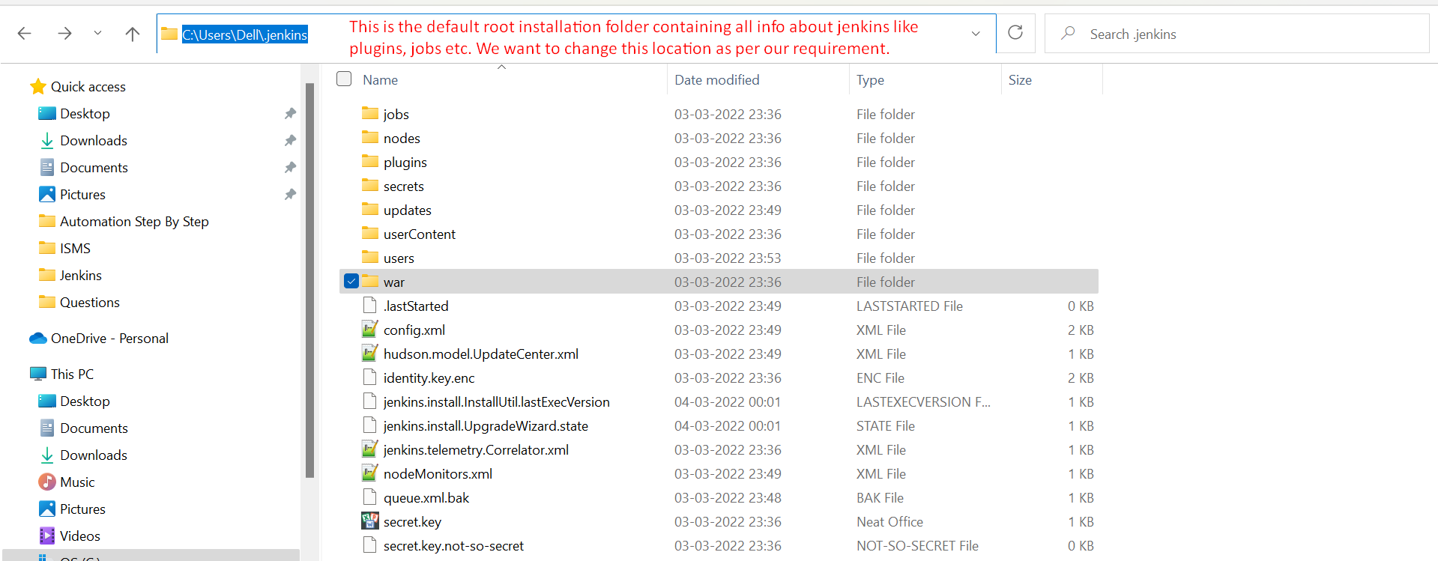
2. 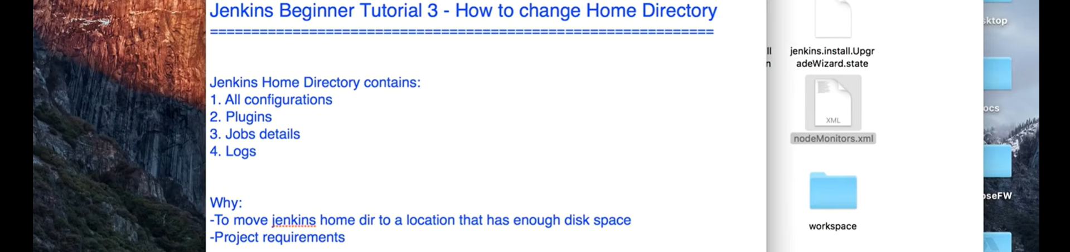
3. There are two ways.
   1. If Jenkins is already existing:
      1. It means that Jenkins was installed under /Users/{user_name}/.jenkins
      2. So, copy all the files from this folder and paste into the new folder.
      3. And also don’t forget to update env jenkins_home (**/Users/{user_name}/.jenkins**)
   2. If running this command first time 🡺 java -jar jenkins.war
      1. Create a new folder as jenkins home dir.
      2. Set env jenkins_home to this new folder.
      3. Then run the command java -jar jenkins.war
4. 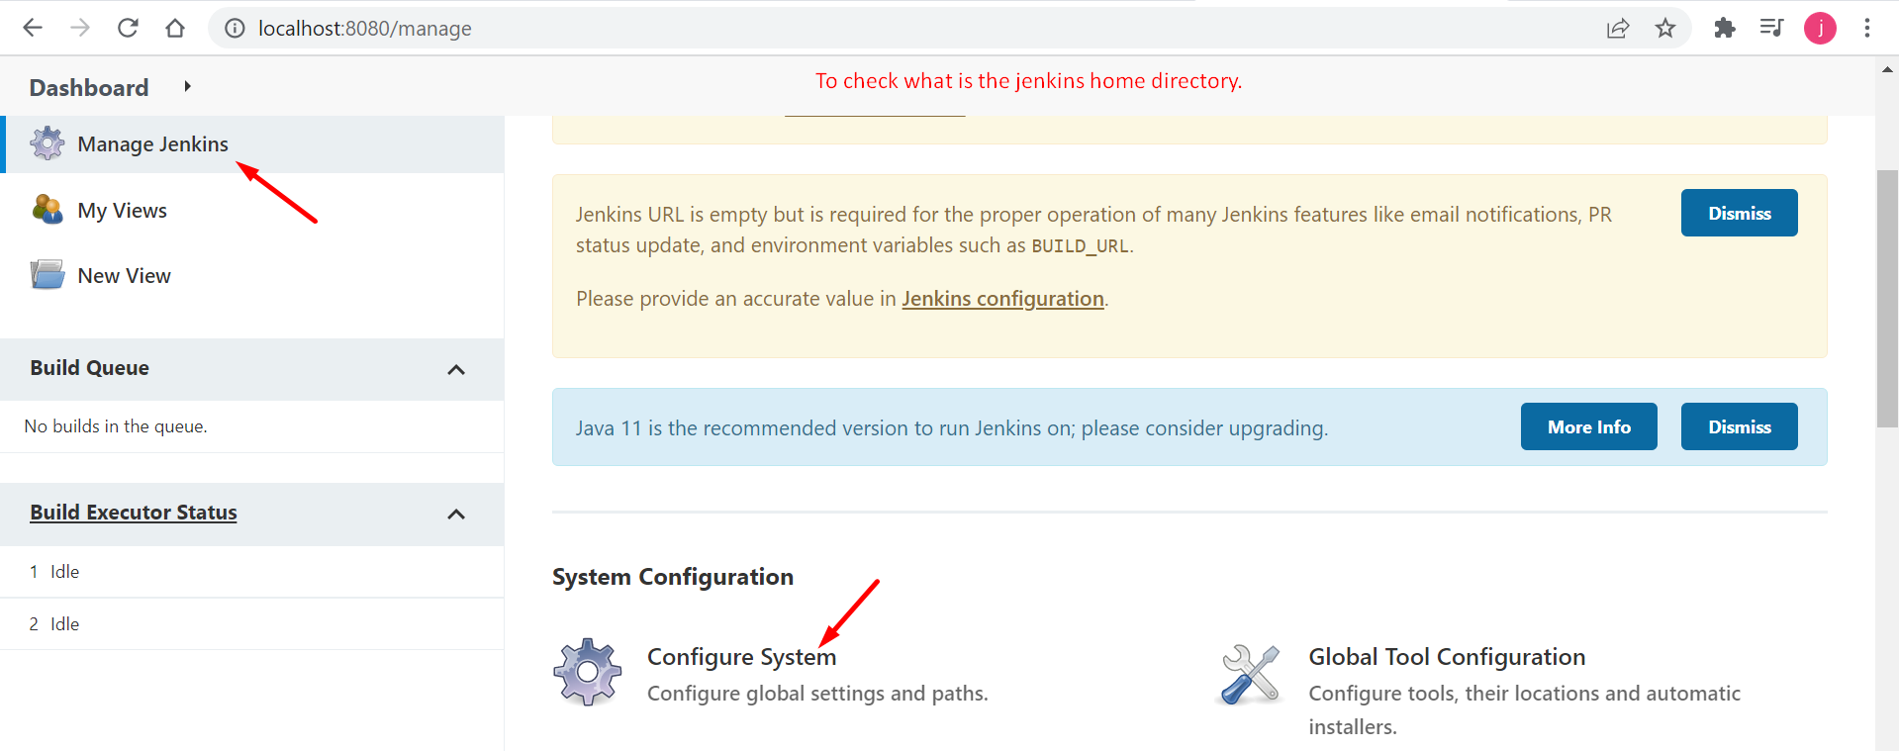
5. 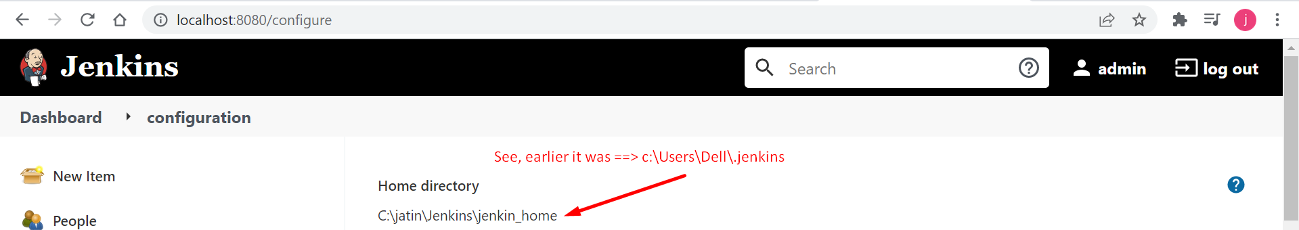
6. 